AI-Based Student Support Assistant using Dialogflow A
PROJECT REPORT
Submitted in the partial fulfillment for the award of the degree of
MLA0104- Artificial Intelligence and Expert Systems

to the award of the degree of
BACHELOR OF TECHNOLOGY
IN
ARTIFICIAL INTELLIGENCE AND MACHINE LEARNING
Submitted by
Vishnu Priya G (192425309)

Under the Supervision of
Dr. Prakash
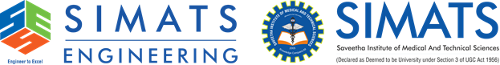

SIMATS ENGINEERING
Saveetha Institute of Medical and Technical Sciences
Chennai-602105
July-2026

Introduction
The increasing use of Artificial Intelligence in education has created new opportunities for improving communication between students and educational institutions. Intelligent conversational systems can understand natural language and provide information without requiring users to search through multiple websites or contact different departments. These systems are useful for handling repetitive questions and delivering information in a simple and accessible manner.
This project focuses on the development of an AI-Based Student Support Assistant using Google Dialogflow. The assistant is designed to respond to common student questions related to academic activities and campus services. By combining intents, entities, training phrases, and predefined responses, the system provides a conversational platform through which students can obtain information quickly and conveniently.

Problem Statement
Students frequently require information about course registration, timetables, attendance, examinations, and campus facilities. In many cases, this information is obtained through separate departments or by directly contacting faculty and administrative staff. This process may be inconvenient and can result in delays, particularly when many students request information at the same time.
The project addresses this issue by creating a conversational assistant capable of handling frequently asked questions. The system provides a centralized communication channel that allows students to enter their questions naturally and receive suitable responses without depending completely on manual assistance.

Objective
The project aims to create a conversational AI system that can understand common student requests and provide relevant information. It focuses on improving the speed and convenience of accessing routine academic and campus-related information through a chatbot interface.
Another objective is to demonstrate the practical use of Artificial Intelligence concepts such as Natural Language Processing, intent classification, entity recognition, and intelligent dialogue management. The project also aims to reduce repetitive queries handled manually by administrative personnel

EXISTING SYSTEM
In a conventional university environment, students obtain information through different sources such as faculty members, adminstrative offices, websites, circulars, and notice boards. Since these sources are not always centralized, students may need to search through multiple channels to find the required information.
This approach also creates repetitive work for staff members because similar questions are asked by many students. During registration and examination periods, the increased number of queries may result in slower communication and delayed responses.

PROPOSED SYSTEM
The proposed solution is a conversational student support system developed using Google Dialogflow. It allows students to communicate with the system using ordinary language instead of following complicated menus or searching through multiple information sources.
When a user enters a query, the chatbot analyzes the message and determines the most suitable intent. It then provides the response associated with that intent. The system is designed to support questions related to course registration, timetables, attendance, examination schedules, and campus facilities.

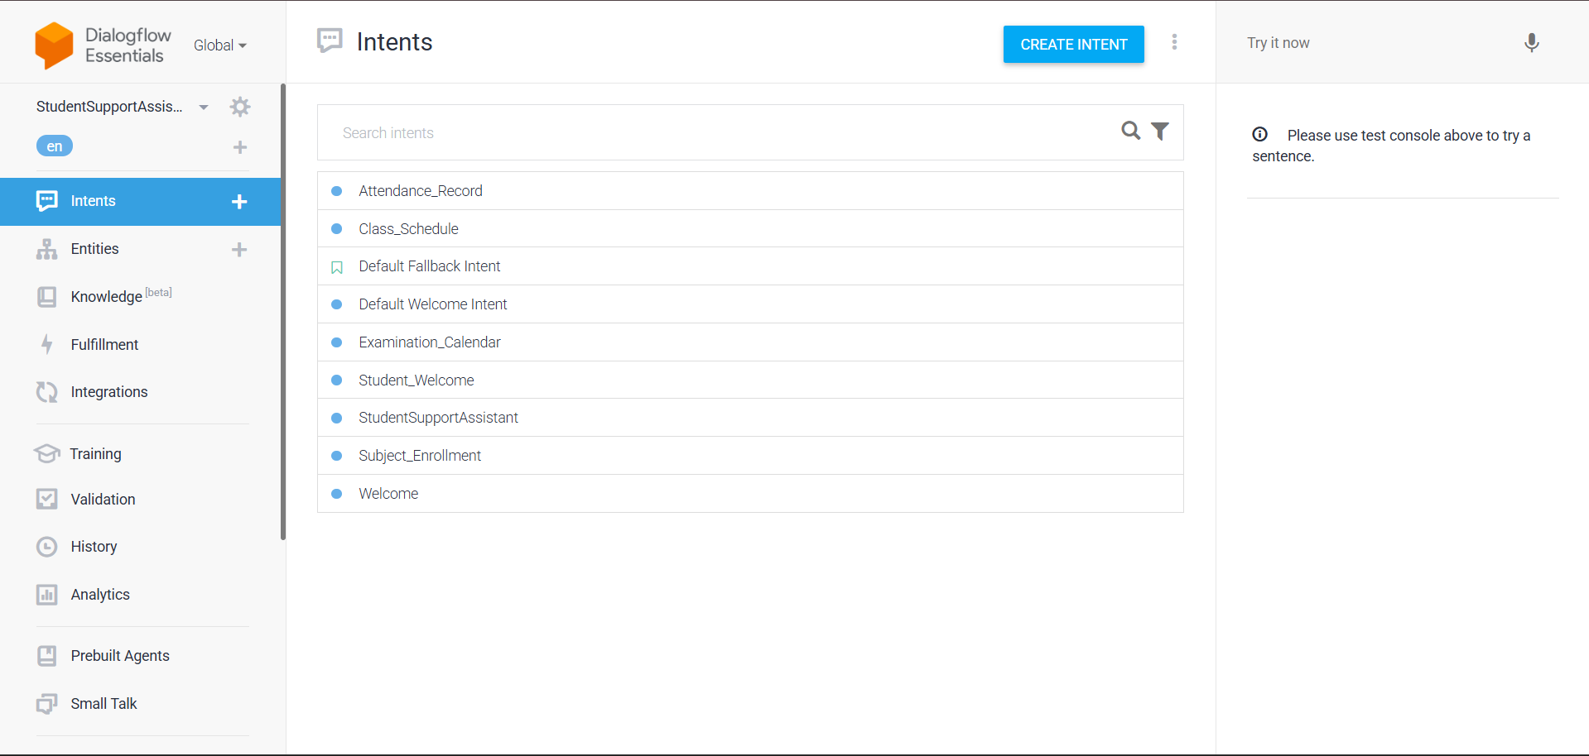

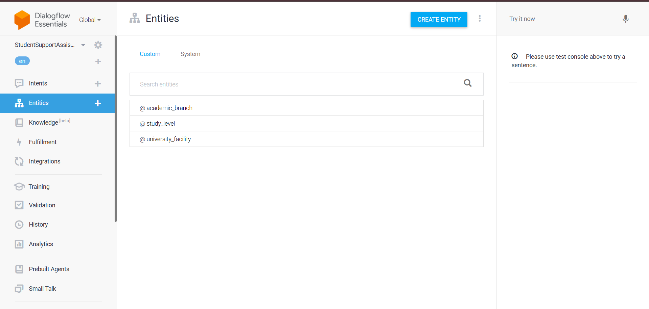

Scope of the Project
The project is intended to support routine information requirements of students within an educational institution. The current chatbot can respond to queries concerning academic procedures, class schedules, attendance-related information, examinations, and selected campus facilities.
The system can be expanded in the future by connecting it with university databases and online student portals. Such improvements could enable personalized services, real-time information retrieval, voice-based interaction, multilingual communication, and mobile application support.

Agent Design
The Student Support Assistant is designed as a conversational software agent that receives a user message and determines the information required by the student. The agent uses the structure of the query to identify the relevant category and then provides an appropriate response.
The design is based on intents, entities, training phrases, and responses. Intents represent the purpose of the user's request, while entities help identify important details included in the query. Training phrases improve the system's ability to recognize different expressions with similar meanings.

Dialogflow Development
Google Dialogflow is used as the development platform for creating and testing the conversational assistant. It provides tools for defining intents, creating entities, adding example user expressions, and configuring responses. The platform also includes a testing interface that makes it possible to verify whether the chatbot correctly identifies different queries.
The chatbot contains intents such as Welcome, Course Registration, Timetable, Attendance, Examination Schedule, Campus Services, and Goodbye. Entities such as Department, Semester, and Service are used to identify important information from student queries. Together, these components form the basic conversational structure of the system.

Conversation Flow
The interaction starts when a student opens the chatbot and enters a greeting or question. The chatbot processes the input and determines which intent is most closely related to the user's request. After identifying the intent, it displays the response configured for that particular requirement.
Once the answer is provided, the chatbot can continue the conversation if the student has another question. When the student finishes the interaction, the system responds with a closing message. This creates a simple sequence of user input, intent identification, response generation, and conversation completion.

Search Strategy
Breadth-First Search is used in this project as a conceptual model for explaining the exploration of possible dialogue categories. The method examines possible choices systematically before reaching the appropriate category. In the chatbot context, the different intents can be viewed as possible paths for handling a user's request.
The actual matching of user queries in Dialogflow is performed using its Natural Language Understanding system. BFS is included as an Artificial Intelligence search concept to explain systematic dialogue navigation and demonstrate how search strategies can be related to conversational agent design.

Testing and Evaluation
Testing is carried out by entering different types of student queries into the chatbot. The purpose of testing is to verify whether the correct intent is recognized and whether the configured response is displayed. Each test case is compared with the expected output to evaluate the behaviour of the system.
The testing process covers greetings, registration questions, timetable requests, attendance queries, examination questions, campus facility requests, and closing messages. Successful recognition of these queries demonstrates that the chatbot is functioning correctly for the defined scenarios.

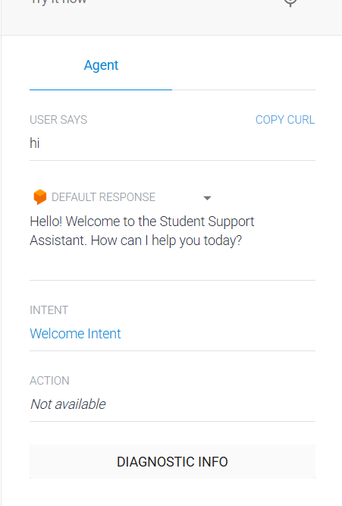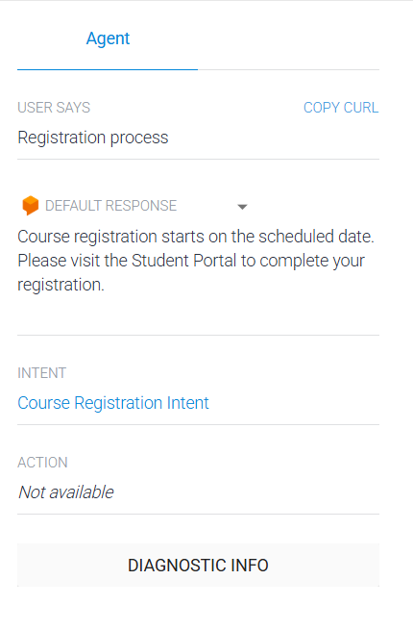

Intent Testing Table
User Input | Expected Response | Detected Intent | Result
Hello | Welcome message | Welcome Intent | Pass
How can I register for a course? | Registration information | Course Registration Intent | Pass
I want to see my class schedule | Timetable information | Timetable Intent | Pass
Tell me about attendance | Attendance information | Attendance Intent | Pass
When are the examinations? | Examination details | Exam Schedule Intent | Pass
Where is the library? | Campusservice information | Campus Services Intent | Pass
Thanks for the information | Closing message | Goodbye Intent | Pass

Entity Testing Table
User Input | Entity | Value Identified | Result
Show timetable for CSE | Department | CSE | Pass
Timetable for third semester | Semester | Third Semester | Pass
What are the library timings? | Service | Library | Pass
Tell me about hostel facilities | Service | Hostel | Pass
I need transport details | Service | Transport | Pass

Advantages
The chatbot provides a convenient method for students to obtain information without waiting for manual assistance. It can handle frequently asked questions quickly and provide consistent responses for common academic and campus-related requirements.
The system also reduces repetitive work for administrative staff and can be modified by adding new intents and responses. Since the chatbot uses a conversational interface, students can interact with it using simple natural language.

Limitations
The current chatbot is limited to the information and intents configured during development. If a user asks a question that is outside the defined training data, the chatbot may not provide the expected response.
The system also does not automatically access real-time student databases. Therefore, personalized details such as individual attendance, marks, or examination results require additional database integration and authentication features.

Future Scope
The chatbot can be connected with university ERP and student information systems to provide personalized academic services. Students could use the assistant to access individual attendance records, examination results, fee details, and other academic information through secure login.
Further improvements may include voice-based communication, support for multiple languages, mobile application integration, and more advanced AI-based response generation. These developments can transform the chatbot into a complete digital student support platform.

Conclusion
The AI-Based Student Support Assistant demonstrates how conversational Artificial Intelligence can be applied to improve student information services. The system uses Google Dialogflow to process natural language queries, identify user intents, recognize entities, and generate suitable responses.
The project provides a simple and effective solution for handling common student queries while reducing repetitive manual communication. It also demonstrates important AI concepts such as Natural Language Processing, intelligent agents, intent recognition, entity extraction, and search strategies. With further development and database integration, the system can become a powerful digital assistant for educational institutions.

